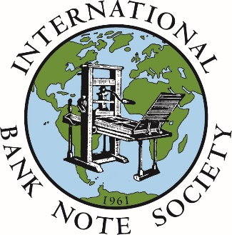 | INTERNATIONAL  BANK NOTE SOCIETY  Application for  Membership | Brian Giese  Membership Secretary for  Western Hemisphere  (including North and South America)  P.O. Box 085745  Racine, WI 53408  UNITED STATES  us-secretary@theibns.org

Family Name |  | Given Name(s)
Address |  | Telephone
 |  | Fax
 |  | Email
 |  | Website
Are you are a member of an IBNS chapter? Yes No If yes, which chapter:
Are you a banknote dealer? Yes No | Introduced by:

Please List Your Collecting Interests

The IBNS Membership Directory is published (in physical, PDF and online formats) to members for the purpose of identifying and establishing contact with fellow members with similar interests. Details provided for publication could be added to mailing lists of banknote dealers, auction houses, museums libraries and other institutions.

Would you like the following details included in the IBNS Membership Directory?
Postal Address Yes No Email Address Yes No Collecting Interests Yes No

ANNUAL MEMBERSHIP FEE (Please Check As Appropriate)
Type Of Membership | USD
- Regular | $36.00
- Junior | $18.00
- Family / Group | $36.00

Please complete and return this form including your first year’s membership fee to the address above.
Alternative payment methods are shown on the reverse of this form.

Please debit my card $36.00 USD

Name (as it appears on your card):

Billing address: (If different from above)

Post Code: Phone Number:
CARD NUMBER
If paying by Visa or MasterCard, add the last 3 digits on the back of your card
If using Amex or Optima, add the 4 digits printed (not embossed) on the front of your card
Signature ______________________________________________________ Expiry date /

For security reasons, credit card details must NOT be sent by email or as an email attachment.
Alternatively fax this credit card payment authority to the IBNS Treasurer +1 636 391 7004

Please return the completed form to the Membership Secretary at the address shown at the top of the form
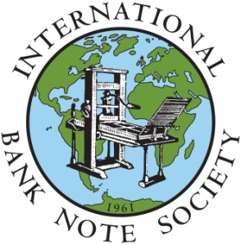
IBNS AIMS AND OBJECTIVES
The IBNS was established in 1961 for educational purposes.

Our formal aims are to promote, stimulate and advance the worldwide collection, study and knowledge of banknotes and paper money.

The International Bank Note Society is the premier society for banknote enthusiasts.

- We publish a quarterly Journal that includes articles dealing with various aspects of paper money, letters to the editor, details of new note issues, book reviews and news from our local chapters.
- We organize postal auctions and support banknote fairs in various parts of the world.
- We have a website (www.theIBNS.org) that you are welcome to visit. Members are entitled to a password to the “members only” areas of the website.
- The IBNS Membership Directory is published every two years and is also only available to members. It contains our bylaws in full, code of ethics, contact details and collecting interests of those members who have agreed to share this information with their fellow members.

On a more formal level, we help to set banknote grading standards and, through our bylaws and code of ethics, establish a sound framework for dealings between members, professional and otherwise. We offer assistance in resolving any disputes arising between members.

PRIVACY POLICY
The IBNS will use contact details provided by members to deliver membership benefits and, where a member has chosen to publish their contact details, to inform other members of a member's name, contact details and collecting interests. The IBNS will not knowingly divulge contact details of a member to an entity who is not a member of the IBNS, unless legally required.
(Full Privacy Policy can be found at www.theIBNS.org or obtained from an IBNS Secretary.)

MEMBERSHIP TYPES
- REGULAR: Any person 18 years of age or older who is interested in paper currency and is in sympathy with the aims and objectives of IBNS may apply for regular membership.
- JUNIOR: Available to young people, under the age of 18, who are interested in paper money. The application for membership has to be endorsed by a parent or legal guardian.
- FAMILY: Family membership issued in the name of an individual applicant who would otherwise be eligible for regular membership. It includes the applicant and immediate family (spouse and minor children) listed on the application.
- GROUP: Non-IBNS-affiliated numismatic firms, clubs or societies, libraries, museums, archives, schools, or similar organizations are eligible for group membership. They pay the same subscription rate as regular individual members.

PAYMENT METHODS
Membership Fees can be paid using one of the following methods:
 | Cheque / Money Order / Cash – US Dollars (USD)  Cheques and Money Orders payable to “I.B.N.S.” or “International Bank Note Society”.  Cash sent at sender’s risk. Registered mail is recommended
PayPal via IBNS Website (www.theIBNS.org/paypal) – US Dollars (USD)
Payments are processed by secure PayPal website; a PayPal account is not required.

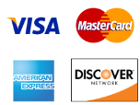 | Credit Card – US Dollars (USD)  Complete the Credit Card Payment Authority below and return via post or fax

Please return the completed form to the Membership Secretary at the address shown on the front of the form

